

**Technical Documentation (SAS 9.4)**

**By:**

[**Krishnakanth Panakarajupally**](http://www.linkedin.com/pub/krishnakanth-panakarajupally/62/93a/470/)

[**krishnakanth.590@gmail.com**](mailto:krishnakanth.590@gmail.com)

* **Creating library “Zappos,” to store datasets.**

LIBNAME Zappos 'C:\sas\myfolders\Zappos\' ;

* **Defining input data file name and location variable**

FILENAME Inp_Data 'C:\Analytics_Challenge_Data_2.csv' ;

* **Importing dataset:**

**DATA** Zappos.Dataset_Crude;

INFILE Inp_Data DELIMITER=',' FIRSTOBS = **2** MISSOVER DSD;

INFORMAT day mmddyy10. platform $15.;

INPUT day $ site $ new_customer platform $ visits distinct_sessions orders gross_sales bounces

add_to_cart product_page_views search_page_views;

**RUN**;

* **Creating new data set named “Dataset_Intermediate”, with metrics: conversion_rate, bounce_rate, add_to_cart_rate:**

**DATA** Zappos.Dataset_Intermediate;

SET Zappos.Dataset_Crude;

Month = MONTH(day); * Extracting month from date ;

day_of_week = WEEKDAY(day); * Extracting day of the week from from date ;

conversion_rate = orders / visits;

bounce_rate = bounces / visits;

add_to_cart_rate = add_to_cart / visits;

* Condition to eliminate observations with missing values ;

WHERE day IS NOT NULL

AND site IS NOT NULL

AND new_customer ^= **.**

AND new_customer ^= **.**

AND platform IS NOT NULL

AND visits ^= **.**

AND distinct_sessions ^= **.**

AND orders ^= **.**

AND gross_sales ^= **.**

AND bounces ^= **.**

AND add_to_cart ^= **.**

AND product_page_views ^= **.**

AND search_page_views ^= **.**;

**RUN**;

* **Creating new dataset named Dataset_NomissingValues, by eliminating records with null metric values.**

**DATA** Zappos.Dataset_NomissingValues;

SET Zappos.Dataset_Intermediate;

WHERE search_page_views ^= **.**

AND conversion_rate ^= **.**

AND bounce_rate ^= **.**

AND add_to_cart_rate ^= **.**;

LABEL

day = 'Day'

site = 'Site'

new_customer = 'New_Customer?'

platform = 'Platform'

visits = 'Visits'

distinct_sessions = 'Distinct Sessions'

orders = 'Orders'

gross_sales = 'Gross Sales'

bounces = 'Bounces'

add_to_cart = 'Add to cart'

product_page_views = 'Prodcut page views'

search_page_views = 'Search page views'

conversion_rate = 'Conversion rate'

bounce_rate = 'Bounce rate'

add_to_cart_rate = 'Add to cart rate';

**RUN**;

**Note:** SAS stores the date values as the number of days between January 1, 1960 and the date entered. Without applying format, the dates will be displayed as numerical values. In similar way, months and days of week are also stored as numerical values. Hence we create formats to format those values.

* **Creating SAS formats to format the values of Month, Day_of_week and New_customer variables:**

**PROC** **FORMAT**;

VALUE MONTH_FMT **1** = 'January'

**2** = 'February'

**3** = 'March'

**4** = 'April'

**5** = 'May'

**6** = 'June'

**7** = 'July'

**8** = 'August'

**9** = 'September'

**10** = 'October'

**11** = 'November'

**12** = 'December';

VALUE WEEK_FMT **1** = 'Sunday'

**2** = 'Monday'

**3** = 'Tuesday'

**4** = 'Wednesday'

**5** = 'Thursday'

**6** = 'Friday'

**7** = 'Saturday';

VALUE CUST_FMT **1** = 'Yes'

**0** = 'No';

VALUE WEEK_FMT_SHORT **1** = 'S'

**2** = 'M'

**3** = 'T'

**4** = 'W'

**5** = 'TH'

**6** = 'F'

**7** = 'SA';

**RUN**;

* **Applying the above created formats and creating final dataset for analysis:**

**DATA** Zappos.Dataset_Final;

SET Zappos.Dataset_NoMissingValues;

* Applying formats ;

FORMAT day mmddyy10. Month MONTH_FMT. day_of_week WEEK_FMT.;

**RUN**;

* **Creating frequency distribution table:**

**PROC** **FREQ** DATA = Zappos.Dataset_Final ;

TITLE "Frequency distribution table";

TABLES site platform month day_of_week / NOCUM ;

**RUN**;

* **Creating correlation matrix:**

**PROC** **CORR** DATA = Zappos.Dataset_Final;

TITLE "Correlation matrix";

VAR visits orders gross_sales distinct_sessions bounces

add_to_cart product_page_views search_page_views conversion_rate bounce_rate add_to_cart_rate;

**RUN;**

* **Creating bar plots:**

* Distribution of Orders by month (Percentage of orders);

PATTERN1 COLOR=VIBG VALUE = S;

PATTERN2 COLOR=STRO VALUE = S;

axis1 label=(a=**90** f="Arial/Bold" "Total number of orders") minor=(n=**5**);

axis2 label= (f="Arial/Bold" "Month of the year");

axis3 label= (f="Arial/Bold" "New Customer?");

**PROC** **GCHART** DATA = Zappos.Dataset_Final;

TITLE "Distribution of Orders by Month (Percentage of orders)";

VBAR Month / SUBGROUP = new_customer

SUMVAR = Orders

TYPE = SUM DISCRETE

OUTSIDE = PERCENTSUM

INSIDE = PERCENTSUM

raxis=axis1

maxis =axis2

gaxis = axis3;

FORMAT new_customer CUST_FMT.;

**RUN**;

* Distribution of Orders by platform ;

PATTERN1 COLOR=VIBG VALUE = S;

PATTERN2 COLOR=STRO VALUE = S;

axis1 label=( f="Arial/Bold" "Total number of orders") minor=(n=**5**);

axis2 label= (a=**90** f="Arial/Bold" "Platform");

**PROC** **GCHART** DATA = Zappos.Dataset_Final;

TITLE "Distribution of Orders by Platform";

HBAR Platform /

SUBGROUP = new_customer

SUMVAR = orders

OUTSIDE = SUM PERCENTSUM

SUMLABEL = 'Orders'

PCTSUMLABEL = 'Percent'

raxis=axis1

maxis =axis2;

FORMAT new_customer CUST_FMT.;

**RUN**;

* Distribution of Orders by site ;

PATTERN1 COLOR=VIBG VALUE = S;

PATTERN2 COLOR=STRO VALUE = S;

axis1 label=(a=**90** f="Arial/Bold" "Total number of orders") minor=(n=**5**);

axis2 label= (f="Arial/Bold" "Platform");

axis3 label= (f="Arial/Bold" "New Customer?");

**PROC** **GCHART** DATA = Zappos.Dataset_Final;

TITLE "Distribution of Orders by Site";

VBAR site /

SUBGROUP = new_customer

SUMVAR = orders

OUTSIDE = PERCENTSUM

raxis=axis1

maxis =axis2

gaxis = axis3;

FORMAT new_customer CUST_FMT.;

**RUN**;

* Distribution of Orders by day_of_week ;

PATTERN1 COLOR=VIBG VALUE = S;

PATTERN2 COLOR=STRO VALUE = S;

axis1 label=(a=**90** f="Arial/Bold" "Total number of orders") minor=(n=**5**);

axis2 label= (f="Arial/Bold" "Day of the week");

**PROC** **GCHART** DATA = Zappos.Dataset_Final;

TITLE "Distribution of Orders by day_of_week";

VBAR day_of_week / DISCRETE

SUBGROUP = new_customer

SUMVAR = orders

TYPE = SUM

OUTSIDE = PERCENTSUM

INSIDE = SUM

raxis=axis1

maxis =axis2;

FORMAT new_customer CUST_FMT.;

**RUN**;

* Distribution of Orders by day_of_week, group by month ;

PATTERN1 COLOR=VIBG VALUE = S;

PATTERN2 COLOR=STRO VALUE = S;

axis1 label=(a=**90** f="Arial/Bold" "Total number of orders") minor=(n=**5**);

axis2 label= (f="Arial/Bold" "Day of the week");

axis2 label= (f="Arial/Bold" "Day of the week");

**PROC** **GCHART** DATA = Zappos.Dataset_Final;

TITLE "Distribution of Orders by day_of_week";

VBAR day_of_week / GROUP = month DISCRETE

SUBGROUP = new_customer

SUMVAR = orders

TYPE = SUM

OUTSIDE = PERCENTSUM

INSIDE = SUM

raxis=axis1

maxis =axis2;

FORMAT new_customer CUST_FMT. day_of_week Week_fmt_short.;

**RUN**;

* **Creating Scatterplots:**

SYMBOL VALUE = DOT COLOR = STRO;

**PROC** **GPLOT** DATA = Zappos.Dataset_Final;

TITLE "Orders Vs Visits";

PLOT orders*visits;

**RUN**;

SYMBOL VALUE = DOT COLOR = RED;

**PROC** **GPLOT** DATA = Zappos.Dataset_Final;

TITLE "Orders Vs Distinct Sessions";

PLOT orders*distinct_sessions;

**RUN**;

SYMBOL VALUE = DOT COLOR = VIBG;

**PROC** **GPLOT** DATA = Zappos.Dataset_Final;

TITLE "Orders Vs Bounces";

PLOT orders*bounces;

**RUN**;

SYMBOL VALUE = DOT COLOR = OliveDrab;

**PROC** **GPLOT** DATA = Zappos.Dataset_Final;

TITLE "Orders Vs Add to cart";

PLOT orders*add_to_cart;

**RUN**;

SYMBOL VALUE = DOT COLOR = DarkGoldenrod;

**PROC** **GPLOT** DATA = Zappos.Dataset_Final;

TITLE "Orders Vs Product page views";

PLOT orders*product_page_views;

**RUN**;

SYMBOL VALUE = DOT COLOR = DarkViolet;

**PROC** **GPLOT** DATA = Zappos.Dataset_Final;

TITLE "Orders Vs Search Page Views";

PLOT orders*search_page_views;

**RUN**;

* **Analysis of Variance (ANOVA):** Checking if there is significant association between quantitative variable: Orders and Categorical variables (Site, Platform, Month, Day of week)

**PROC** **ANOVA** DATA = Zappos.Dataset_Final;

TITLE "Orders vs Site";

CLASS site;

MODEL orders = site;

MEANS site / snk;

**RUN**;

**QUIT**;

**PROC** **ANOVA** DATA = Zappos.Dataset_Final;

TITLE "Orders vs Platform";

CLASS platform;

MODEL orders = platform;

MEANS platform / snk;

**RUN**;

**QUIT**;

**PROC** **ANOVA** DATA = Zappos.Dataset_Final;

TITLE "Orders vs Month";

CLASS month;

MODEL orders = month;

MEANS month / snk;

**RUN**;

**QUIT**;

**PROC** **ANOVA** DATA = Zappos.Dataset_Final;

TITLE "Orders vs Day of Week";

CLASS day_of_week;

MODEL orders = day_of_week;

MEANS day_of_week / snk;

**RUN**;

**QUIT**;

**Note:** In order to use categorical variables in regression model, they must be converted into dummy variables. Reference coding is used for dummy variables. If there are N number of values for a categorical variable, N-1 number of variables will be created.

* **Creating dummy variables:**

**DATA** Zappos.Dataset_final_dummies;

SET Zappos.Dataset_final;

* Dummy variables for site ;

IF site = 'Acme' THEN

DO

site_botly = **0** ;

site_pinnacle = **0** ;

site_sortly = **0** ;

site_tabular = **0** ;

site_widgetry = **0**;

END;

ELSE IF site = 'Botly' THEN

DO

site_botly = **1** ;

site_pinnacle = **0** ;

site_sortly = **0** ;

site_tabular = **0** ;

site_widgetry = **0**;

END;

ELSE IF site = 'Pinnacle' THEN

DO

site_botly = **0** ;

site_pinnacle = **1** ;

site_sortly = **0** ;

site_tabular = **0** ;

site_widgetry = **0**;

END;

ELSE IF site = 'Sortly' THEN

DO

site_botly = **0** ;

site_pinnacle = **0** ;

site_sortly = **1** ;

site_tabular = **0** ;

site_widgetry = **0**;

END;

ELSE IF site = 'Tabular' THEN

DO

site_botly = **0** ;

site_pinnacle = **0** ;

site_sortly = **0** ;

site_tabular = **1** ;

site_widgetry = **0**;

END;

ELSE IF site = 'Widgetry' THEN

DO

site_botly = **0** ;

site_pinnacle = **0** ;

site_sortly = **0** ;

site_tabular = **0** ;

site_widgetry = **1**;

END;

* Dummy variables for Platform ;

IF platform = 'Android' THEN

DO

platform_blackberry = **0** ;

platform_chromeos = **0**;

platform_ios = **0**;

platform_ipad = **0**;

platform_iphone = **0**;

platform_linux = **0**;

platform_macintosh = **0**;

platform_macosx = **0**;

platform_other = **0**;

platform_unknown = **0**;

platform_windows = **0**;

platform_windowsphone = **0**;

END;

ELSE IF platform = 'BlackBerry' THEN

DO

platform_blackberry = **1** ;

platform_chromeos = **0**;

platform_ios = **0**;

platform_ipad = **0**;

platform_iphone = **0**;

platform_linux = **0**;

platform_macintosh = **0**;

platform_macosx = **0**;

platform_other = **0**;

platform_unknown = **0**;

platform_windows = **0**;

platform_windowsphone = **0**;

END;

ELSE IF platform = 'ChromeOS' THEN

DO

platform_blackberry = **0** ;

platform_chromeos = **1**;

platform_ios = **0**;

platform_ipad = **0**;

platform_iphone = **0**;

platform_linux = **0**;

platform_macintosh = **0**;

platform_macosx = **0**;

platform_other = **0**;

platform_unknown = **0**;

platform_windows = **0**;

platform_windowsphone = **0**;

END;

ELSE IF platform = 'iOS' THEN

DO

platform_blackberry = **0** ;

platform_chromeos = **0**;

platform_ios = **1**;

platform_ipad = **0**;

platform_iphone = **0**;

platform_linux = **0**;

platform_macintosh = **0**;

platform_macosx = **0**;

platform_other = **0**;

platform_unknown = **0**;

platform_windows = **0**;

platform_windowsphone = **0**;

END;

ELSE IF platform = 'iPad' THEN

DO

platform_blackberry = **0** ;

platform_chromeos = **0**;

platform_ios = **0**;

platform_ipad = **1**;

platform_iphone = **0**;

platform_linux = **0**;

platform_macintosh = **0**;

platform_macosx = **0**;

platform_other = **0**;

platform_unknown = **0**;

platform_windows = **0**;

platform_windowsphone = **0**;

END;

ELSE IF platform = 'iPhone' THEN

DO

platform_blackberry = **0** ;

platform_chromeos = **0**;

platform_ios = **0**;

platform_ipad = **0**;

platform_iphone = **1**;

platform_linux = **0**;

platform_macintosh = **0**;

platform_macosx = **0**;

platform_other = **0**;

platform_unknown = **0**;

platform_windows = **0**;

platform_windowsphone = **0**;

END;

ELSE IF platform = 'Linux' THEN

DO

platform_blackberry = **0** ;

platform_chromeos = **0**;

platform_ios = **0**;

platform_ipad = **0**;

platform_iphone = **0**;

platform_linux = **1**;

platform_macintosh = **0**;

platform_macosx = **0**;

platform_other = **0**;

platform_unknown = **0**;

platform_windows = **0**;

platform_windowsphone = **0**;

END;

ELSE IF platform = 'Macintosh' THEN

DO

platform_blackberry = **0** ;

platform_chromeos = **0**;

platform_ios = **0**;

platform_ipad = **0**;

platform_iphone = **0**;

platform_linux = **0**;

platform_macintosh = **1**;

platform_macosx = **0**;

platform_other = **0**;

platform_unknown = **0**;

platform_windows = **0**;

platform_windowsphone = **0**;

END;

ELSE IF platform = 'MacOSX' THEN

DO

platform_blackberry = **0** ;

platform_chromeos = **0**;

platform_ios = **0**;

platform_ipad = **0**;

platform_iphone = **0**;

platform_linux = **0**;

platform_macintosh = **0**;

platform_macosx = **1**;

platform_other = **0**;

platform_unknown = **0**;

platform_windows = **0**;

platform_windowsphone = **0**;

END;

ELSE IF platform = 'Other' THEN

DO

platform_blackberry = **0** ;

platform_chromeos = **0**;

platform_ios = **0**;

platform_ipad = **0**;

platform_iphone = **0**;

platform_linux = **0**;

platform_macintosh = **0**;

platform_macosx = **0**;

platform_other = **1**;

platform_unknown = **0**;

platform_windows = **0**;

platform_windowsphone = **0**;

END;

ELSE IF platform = 'Unknown' THEN

DO

platform_blackberry = **0** ;

platform_chromeos = **0**;

platform_ios = **0**;

platform_ipad = **0**;

platform_iphone = **0**;

platform_linux = **0**;

platform_macintosh = **0**;

platform_macosx = **0**;

platform_other = **0**;

platform_unknown = **1**;

platform_windows = **0**;

platform_windowsphone = **0**;

END;

ELSE IF platform = 'Windows' THEN

DO

platform_blackberry = **0** ;

platform_chromeos = **0**;

platform_ios = **0**;

platform_ipad = **0**;

platform_iphone = **0**;

platform_linux = **0**;

platform_macintosh = **0**;

platform_macosx = **0**;

platform_other = **0**;

platform_unknown = **0**;

platform_windows = **1**;

platform_windowsphone = **0**;

END;

ELSE IF platform = 'WindowsPhone' THEN

DO

platform_blackberry = **0** ;

platform_chromeos = **0**;

platform_ios = **0**;

platform_ipad = **0**;

platform_iphone = **0**;

platform_linux = **0**;

platform_macintosh = **0**;

platform_macosx = **0**;

platform_other = **0**;

platform_unknown = **0**;

platform_windows = **0**;

platform_windowsphone = **1**;

END;

* Dummy variables for Month ;

IF month = **1** THEN

DO

month_february = **0**;

month_march = **0**;

month_april = **0**;

month_may= **0**;

month_june= **0**;

month_july= **0**;

month_august= **0**;

month_september= **0**;

month_october= **0**;

month_november= **0**;

month_december= **0**;

END;

IF month = **2** THEN

DO

month_february = **1**;

month_march = **0**;

month_april = **0**;

month_may= **0**;

month_june= **0**;

month_july= **0**;

month_august= **0**;

month_september= **0**;

month_october= **0**;

month_november= **0**;

month_december= **0**;

END;

IF month = **3** THEN

DO

month_february = **0**;

month_march = **1**;

month_april = **0**;

month_may= **0**;

month_june= **0**;

month_july= **0**;

month_august= **0**;

month_september= **0**;

month_october= **0**;

month_november= **0**;

month_december= **0**;

END;

IF month = **4** THEN

DO

month_february = **0**;

month_march = **0**;

month_april = **1**;

month_may= **0**;

month_june= **0**;

month_july= **0**;

month_august= **0**;

month_september= **0**;

month_october= **0**;

month_november= **0**;

month_december= **0**;

END;

IF month = **5** THEN

DO

month_february = **0**;

month_march = **0**;

month_april = **0**;

month_may= **1**;

month_june= **0**;

month_july= **0**;

month_august= **0**;

month_september= **0**;

month_october= **0**;

month_november= **0**;

month_december= **0**;

END;

IF month = **6** THEN

DO

month_february = **0**;

month_march = **0**;

month_april = **0**;

month_may= **0**;

month_june= **1**;

month_july= **0**;

month_august= **0**;

month_september= **0**;

month_october= **0**;

month_november= **0**;

month_december= **0**;

END;

IF month = **7** THEN

DO

month_february = **0**;

month_march = **0**;

month_april = **0**;

month_may= **0**;

month_june= **0**;

month_july= **1**;

month_august= **0**;

month_september= **0**;

month_october= **0**;

month_november= **0**;

month_december= **0**;

END;

IF month = **8** THEN

DO

month_february = **0**;

month_march = **0**;

month_april = **0**;

month_may= **0**;

month_june= **0**;

month_july= **0**;

month_august= **1**;

month_september= **0**;

month_october= **0**;

month_november= **0**;

month_december= **0**;

END;

IF month = **9** THEN

DO

month_february = **0**;

month_march = **0**;

month_april = **0**;

month_may= **0**;

month_june= **0**;

month_july= **0**;

month_august= **0**;

month_september= **1**;

month_october= **0**;

month_november= **0**;

month_december= **0**;

END;

IF month = **10** THEN

DO

month_february = **0**;

month_march = **0**;

month_april = **0**;

month_may= **0**;

month_june= **0**;

month_july= **0**;

month_august= **0**;

month_september= **0**;

month_october= **1**;

month_november= **0**;

month_december= **0**;

END;

IF month = **11** THEN

DO

month_february = **0**;

month_march = **0**;

month_april = **0**;

month_may= **0**;

month_june= **0**;

month_july= **0**;

month_august= **0**;

month_september= **0**;

month_october= **0**;

month_november= **1**;

month_december= **0**;

END;

IF month = **12** THEN

DO

month_february = **0**;

month_march = **0**;

month_april = **0**;

month_may= **0**;

month_june= **0**;

month_july= **0**;

month_august= **0**;

month_september= **0**;

month_october= **0**;

month_november= **0**;

month_december= **1**;

END;

**RUN**;

* **Generating regression model:**

SYMBOL VALUE = DOT COLOR = RED;

**PROC** **REG** DATA = Zappos.Dataset_final_dummies OUTEST = Zappos.Estimates PLOTS(MAXPOINTS = **11000**);

Predicted_Sales: MODEL gross_sales = new_customer visits bounce_rate add_to_cart_rate

site_botly

site_pinnacle

site_sortly

site_tabular

site_widgetry

platform_blackberry

platform_ios

platform_ipad

platform_iphone

platform_linux

platform_chromeos

platform_macintosh

platform_macosx

platform_other

platform_unknown

platform_windows

platform_windowsphone

month_february

month_march

month_april

month_may

month_june

month_july

month_august

month_september

month_october

month_november

month_december / SELECTION = stepwise VIF;

PLOT RESIDUAL.*PREDICTED.;

**RUN**;

**QUIT**;

**Note:**

* The regression coefficients are saved in a dataset named “Estimates”, so that we can use the coefficients to score the model.
* Several regression models were created by using several combinations of independent variables and the best model was presented in the presentation.
* Acceptable Variance Inflation Factor (VIF) for regression coefficients is assumed as 10.
* Below is the screenshot of the regression coefficients which was generated by including all the variables in the model:
  + 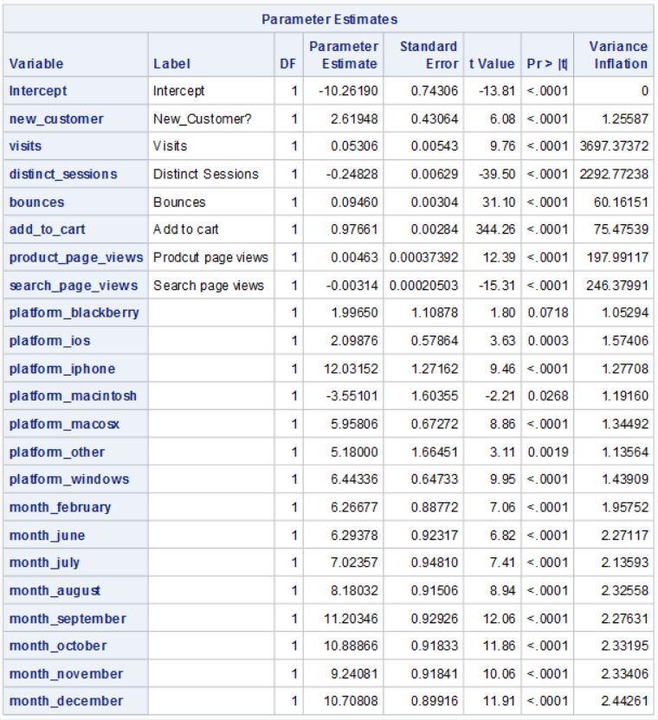
* In the residual plot, a pattern can be observed, which shows that the prediction error increases as the predicted value increases.

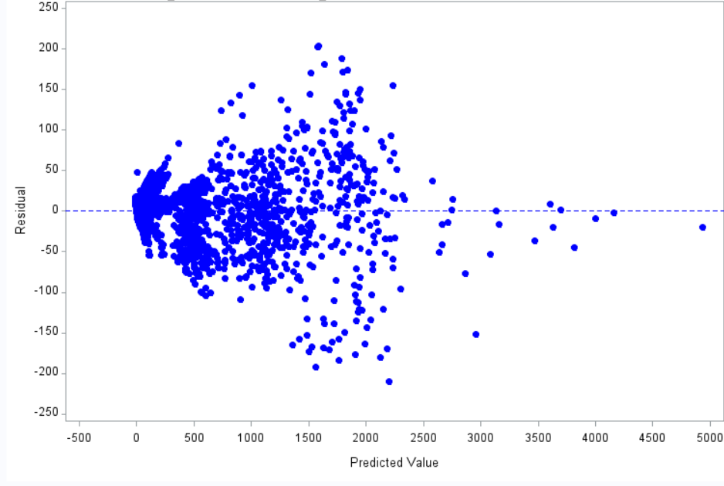

* Since there is high multicollinearity between independent variables, the Variance Inflation Factor (VIF) of regression coefficients is exceeding the acceptable range. Hence, some of the variables were eliminated to make the model stable.
* Below is the screenshot of regression coefficients after eliminating redundant independent variables:

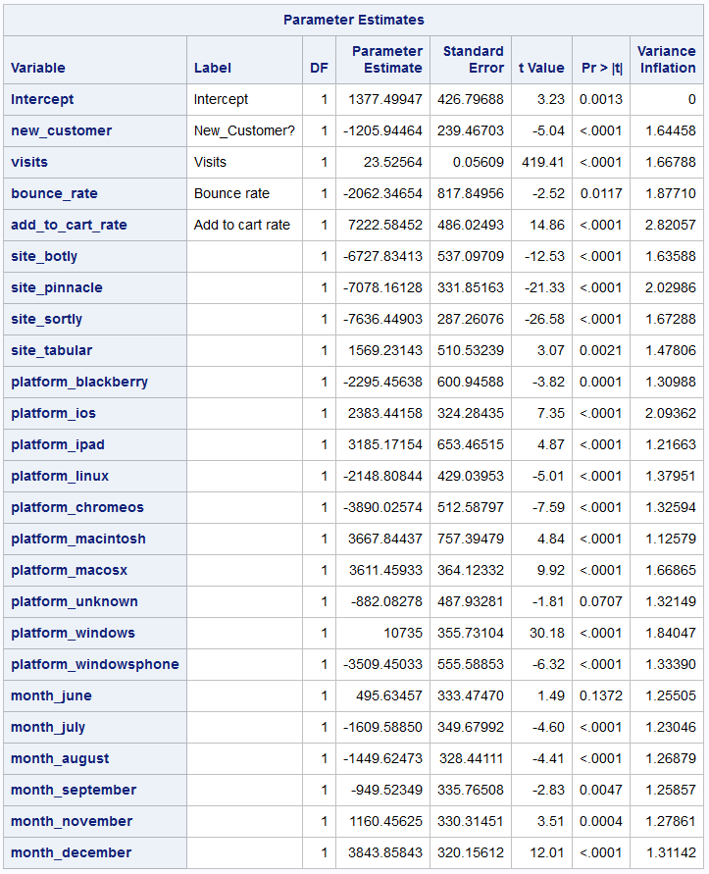

* **Scoring the regression model using PROC SCORE:**

**PROC** **SCORE** DATA = Zappos.Dataset_final_dummies SCORE = Zappos.Estimates TYPE = PARMS OUT = Zappos.Scored_Data;

VAR new_customer visits bounce_rate add_to_cart_rate

site_botly

site_pinnacle

site_sortly

site_tabular

platform_blackberry

platform_ios

platform_ipad

platform_linux

platform_chromeos

platform_macintosh

platform_macosx

platform_unknown

platform_windows

platform_windowsphone

month_june

month_july

month_august

month_september

month_november

month_december;

ID gross_sales;

**RUN**;

**QUIT**;

* **Creating a dataset with predicted values and residuals:**

**DATA** Zappos.Residuals;

SET Zappos.scored_data;

residual = gross_sales-Predicted_sales;

**RUN**;

* **Calculating the sum of residuals and drawing histogram of residuals.**

**PROC** **UNIVARIATE** DATA = Zappos.Residuals;

VAR residual;

HISTOGRAM residual / NORMAL;

**RUN**;